3

ABSTRACT

The idea is to create a smart and secure vault. This vault will be used as a private storage area to store documents, images, pdf, etc. The access to this vault will be controlled by a secure RFID system built on Arduino board with MFRC 522 reader. Further there will be a second, two factor authentication that will be controlled by a PIN. Also, the vault will be hidden from outside world and the execution permission of the vault will be provided only after authentication. Basic Ideology behind this project is to move sensitive data from a less secured open file system to a specifically designed, secured folder or vault. We will be using Incremental Process Model to determine the Life Cycle of our project. We have chosen this model as it provides flexibility to us for adding further specifications in form of independent modules. One more reason because of which we have chosen this model is that it will help us in getting at least some workable modules before our every deadline.

Keywords: RFID, Security, Serial Port, Arduino, CIA, C, gcc, avgcc, PIN

4
TABLE OF CONTENTS
Contents

- Introduction

- Literature Review

- Problem Statement

- Objective

- Design Methodology

- System Requirements

- Implementation
  - Pseudo Code
  - Output Screen
  - Result Analysis
- References

- APPENDIX 1 - Source Code

- APPENDIX 2 – Requirements Survey

5

LIST OF TABLES

List of Tables

1 First table 14

LIST OF FIGURES

List of Figures

- Level 0 DFD 7

- Level 1 DFD 8

- Use Case Diagram 9

- Activity diagram 10

- Sequence Diagram 11

- Statechart Diagram 12

- Collaboration Diagram 13

6

1 Introduction

Security is one of the most important aspect of current world scenario. Data being the most important and private part of our lives, needs to be protected and for that purpose we need to implement various security controls at all places which are involved in dealing with our data. Security controls refer to the mechanisms used to restrict the access to the data or assets so as to maintain confidentiality, integrity and availability thus maintaining the CIA Triad. Daily, people deal with various sensitive documents which need to be protected.

A vault is nothing but a simple solution to deal with this problem. It is a storage area rather say a folder which will be used to keep these sensitive documents.

Arduino Board is a development board used to create various hardware devices due to its characteristics of storing on Board software code. We will be using Arduino UNO R3 Board with 16 IO pins that will help us connect a MFRC 522 simple RFID reader & writer module. Arduino generally works on a library <Arduino.h> developed in C which involves all the major functions required for using Arduino board.

RFID refers to Radio Frequency Identification. It is a technology used in access control systems and Identification Management Systems. It uses two components: -

1.RFID Tag: - This is a storage module i.e. it stores a unique RFID identification number in the form of binary hash values. The RFID tag comes in different shapes and sizes. Depending on the use, any of the tags can be taken in usage.

2.RFID Reader/ Writer: -This device is used to read the data from the RFID tag and decrypt it so that we can use the identification number in our management system.

Also, we will be using Linked Lists. Linked List is a data structure used to store data dynamically with run time memory allocation. We will be using Doubly Linked List so as to have back and forth flexible traversing. In this we will be having an additional pointer which will be used in node hiding.

- Literature Review

- Software Engineering by K.K. Aggarwal & Yogesh Singh Third Edition published by New Age International Publishers 2008 - We have used this resource to study about various life cycle Models and take the best suitable model for our project.

- RFID Based Security and Access Control System IACSIT International Journal of Engineering and Technology, Vol. 6, No. 4, August 2014 Author Prof. Umar Farooq -
This resource was used to study about the usage of RFID tags in access management systems. It told us about RFID tags, storing formats, storage format, etc.

- Working principle of Arduino and using it as a tool for study and research International Journal of Control, Automation, Communication and Systems (IJCACS), Vol.1, No.2, April 2016 Author Leo Louis -
This paper introduced us to Arduino boards and the usage of the pins in Arduino UNO R3. It also told us about linking Arduino and MFRC module.

7

- Problem Statement

We need to create a secure storage which can be used to store and hide important documents and the access to this storage should be secured with some smart technology.

- Objective

- Create a storage area
- The data in the area should be secured
- We should be able to hide the data in this area
- Implement RFID control
- Implement 2 factor PIN
- Restrict Read, Write outside the vault

- Design Methodology

Since, we are using the Incremental SDLC Model thus our methodology will be including all the phases of that model.

System Feasibility: - We will be analyzing the feasibility of our product that whether it will be implementable or not. This phase has already been completed during the title analysis.

Software Plans & Requirements: - During this phase we analyzed all the requirements and planned the development cycle.

Product Design: - We will be developing zero Level DFD in this phase to know what modules are needed for this product.

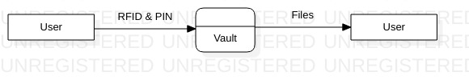
Figure 1

*This will mark the end of requirement verification

8
Detailed Design: - Here we will work on Level 1 DFD to show sub modules and implementable functions. We will be also working on developing the required Use Case diagram.

Level 1 DFD

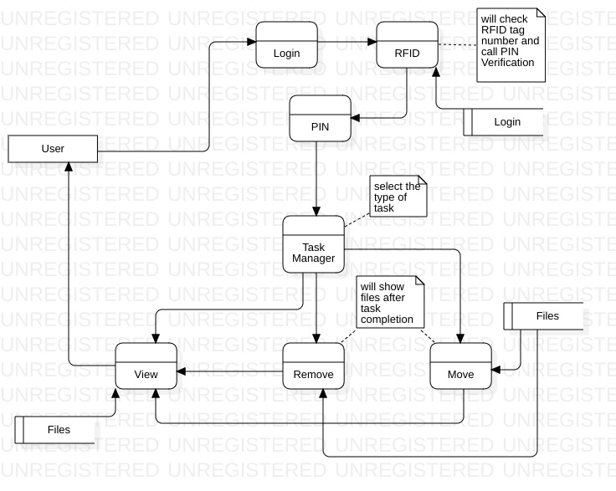
Figure 2

9
Use Case Diagram

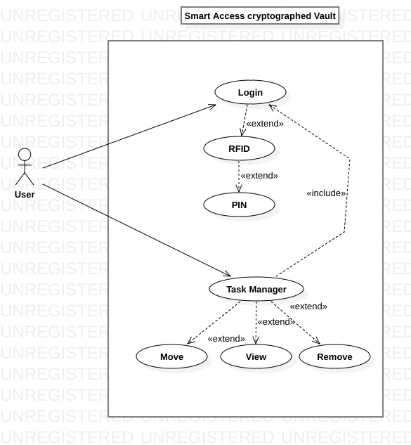
Figure 3

10

Activity Diagram
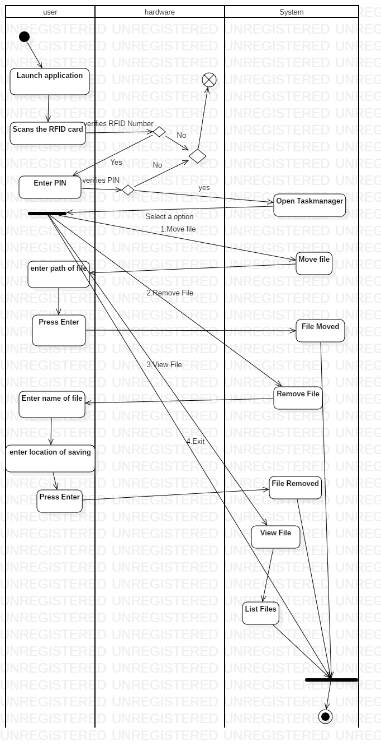
Figure 4

11
Sequence Diagram
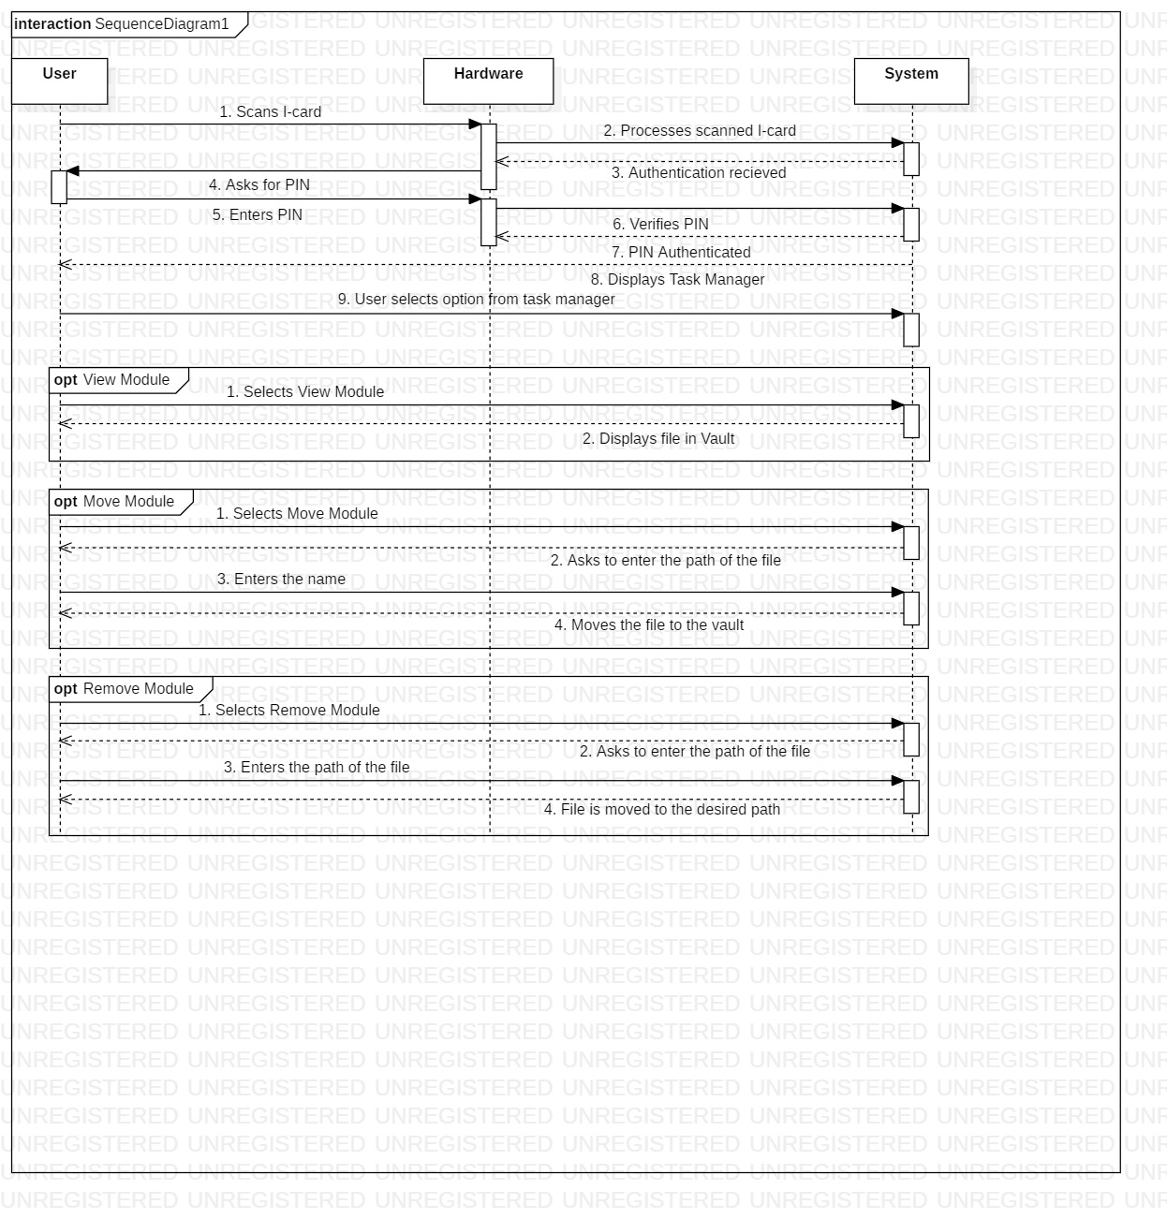
Figure 5

12
Statechart Diagram
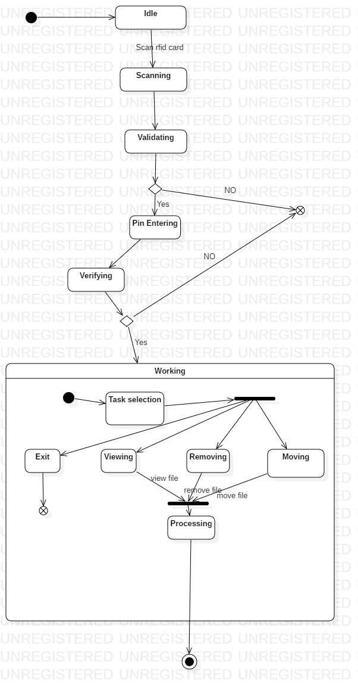
Figure 6

13
Collaboration Diagram
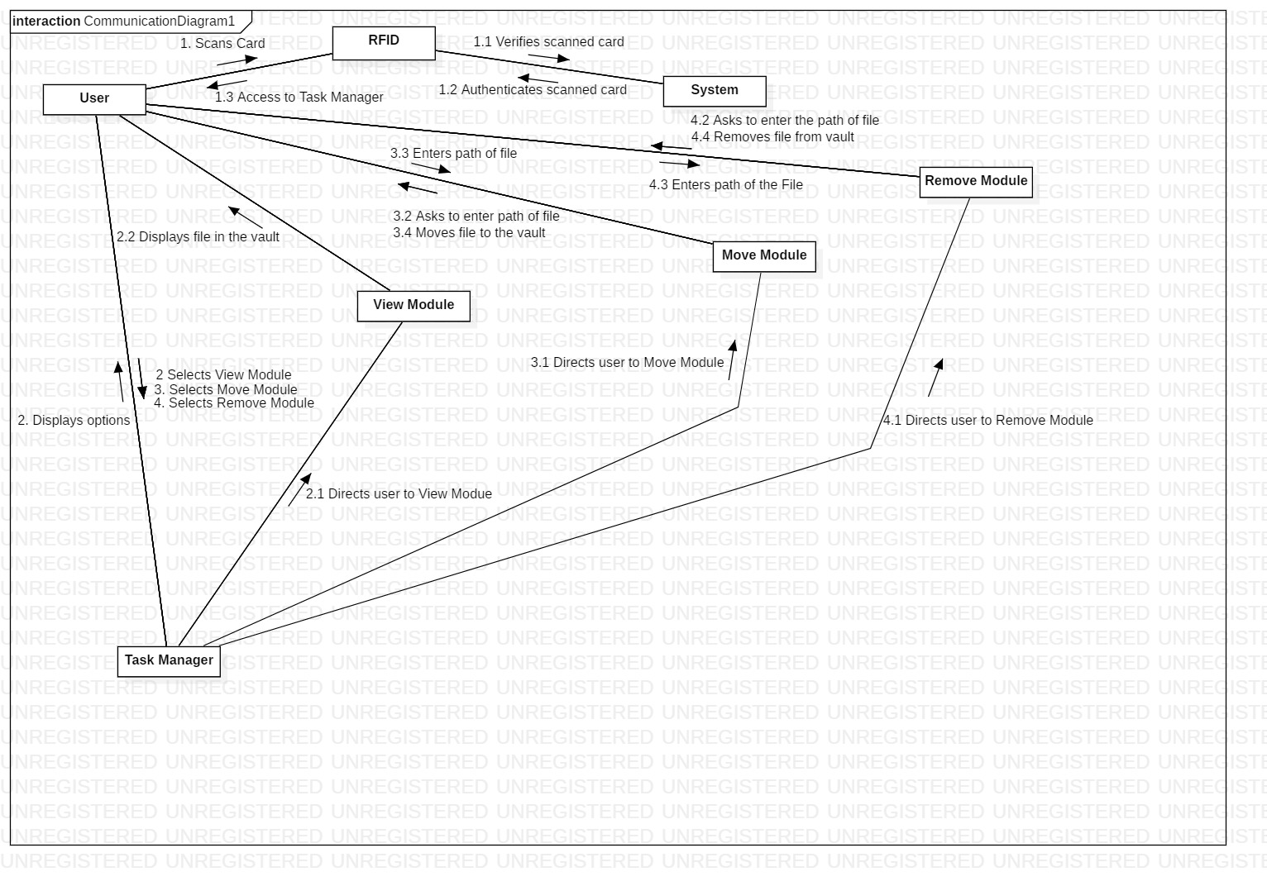
Figure 7
Code: - This will be our main phase which will be our implementation phase where we will code all the modules. Here we will also do the unit testing.

Integration: - This phase will aim at making the product out of the modules i.e. we will be merging the modules.

Implementation: - This will be our system testing phase. We will test all the merged modules. This will act as level one testing for our product.

Operations & Maintenance: - This is our last phase where will work towards achieving feedback and further improvements will be done accordingly.

14
6 System Requirements

Hardware:
- Arduino Board
- MFRC 522 RFID Reader
- Connecting Wires
- Bread Board
- 4 GB Ram
- Intel Core i3 64 bit Processor
- Input and Output Devices
Software:
- Ubuntu 18.04 LTS
- Arduino IDE
- gcc compiler
- Text editor

- Implementation

The vault access will be controlled by RFID card along with a secure PIN. The files will be moved inside the vault using linux commands and the permission to access vault will only be given upon authorization and authentication.

7.1 Pseudocode

The access will be controlled by an Arduino Board UNO R3. The Arduino will read the RFID card using MFRC 522 Module and send the read RFID to serial port. The Arduino will then compare the RFID ID with the one already fed in the code and if it matched, it will send a flag value to the serial output port.

Pin Layout

SDA | Digital 10
SCK | Digital 13
MOSI | Digital 11
MISO | Digital 12
IRQ | Unconnected
GND | GND
RST | Digital 9
3.3V | 3.3V
Table 1

The C program code will fetch the flag value from serial port and compare it with the set flag value. If the flag value matches, then the access will be granted else the access will be restricted.

Upon the successful authentication, a secondary PIN will be asked for 2 step validation.

15
Also, upon the first boot up a new folder named vault will be created and it will be hidden.
For every move or remove operation first the user will need to acquire read, write and execute permission and after that he can perform any task. Post the task completion the permissions are reverted back.

The first screen will show the menu having 3 options namely –
- Move
- Remove
- View

These three options will refer to the functionalities of the product. The move and remove module will work with help of file path and cp command and the view module will work with the help of ls –a command.

7.2 Output Screen

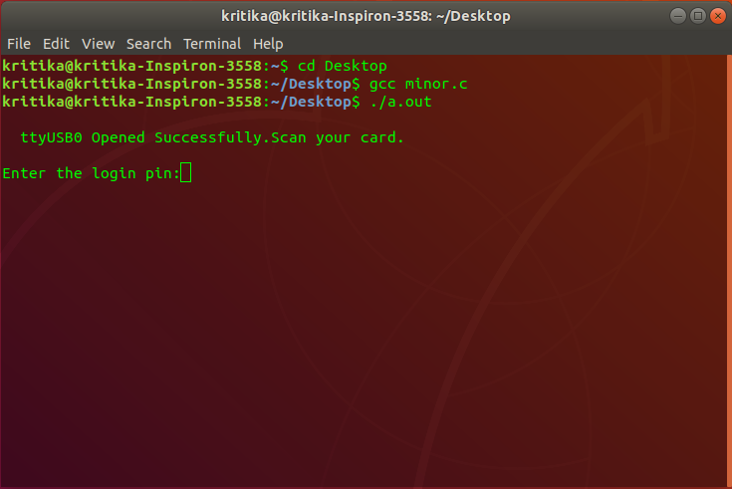

16

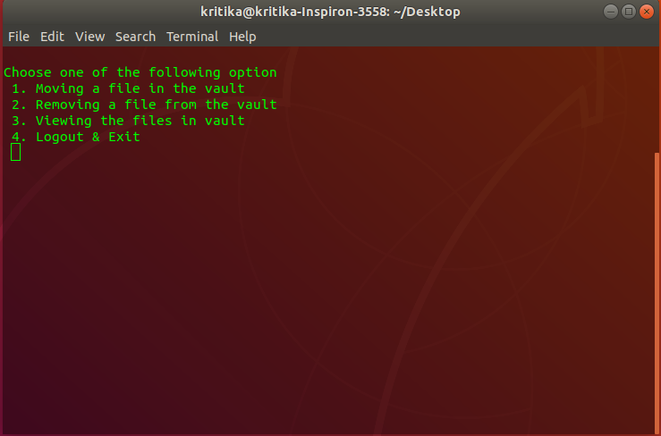

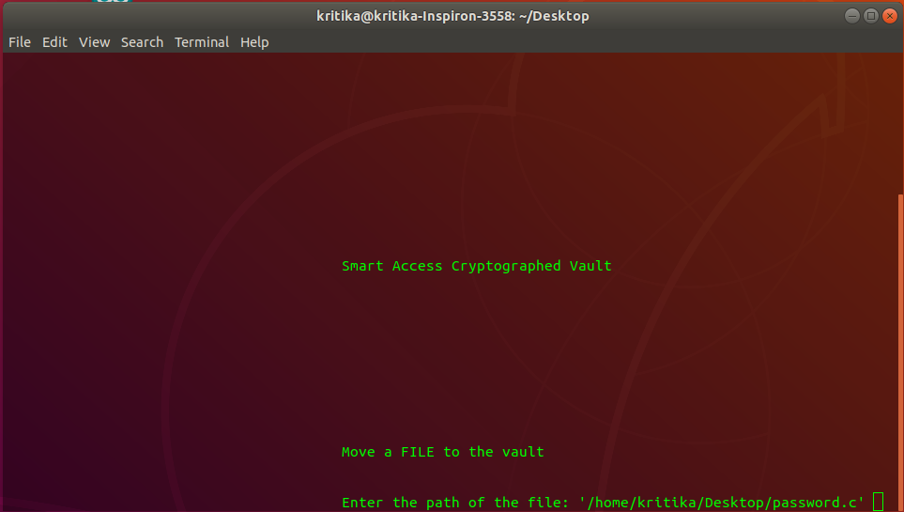

17

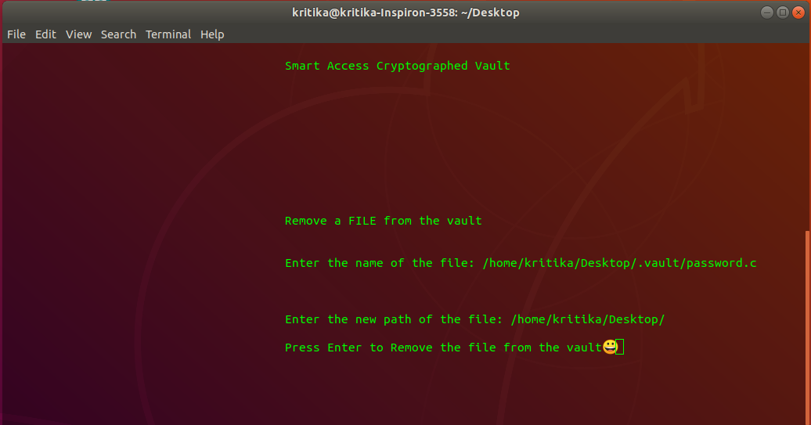

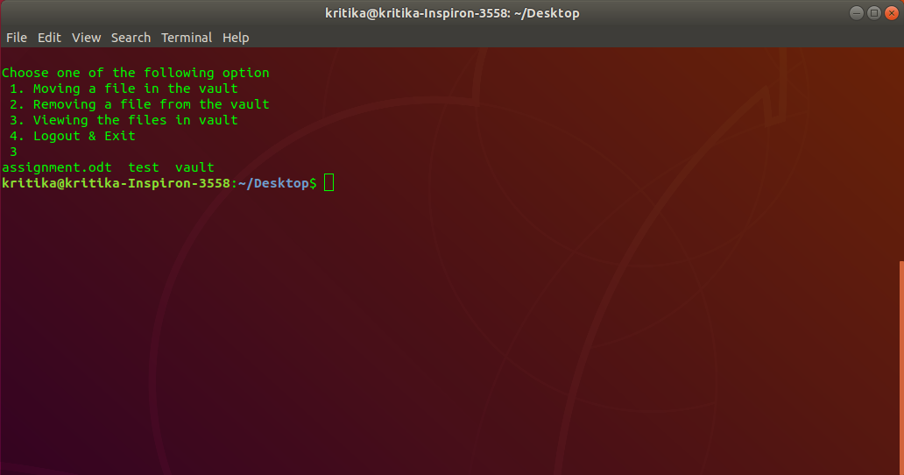

18

7.3 Result Analysis

We have finally succeeded in creating a secure vault with the successful integration of RFID and PIN. This vault satisfies all the user needs and contains all the mentioned functionalities. The final unit and integration testing resulted in zero errors. Further new improvements will be added as part of the maintenance phase.

8. References

- Software Engineering by K.K. Aggarwal & Yogesh Singh Third Edition published by New Age International Publishers 2008 – (27th August 2018)

- https://www.researchgate.net/profile/Umar_Farooq41/publication/275685766_RFID_Based_Security_and_Access_Control_System/links/57f79c5308ae280dd0bcaed7/RFID-Based-Security-and-Access-Control-System.pdf?origin=publication_detail
– (22 August 2018)

- https://airccse.com/ijcacs/papers/1216ijcacs03.pdf - (1st September 2018)
19

APPENDIX I Source Code

#include <stdio.h>
#include <stdlib.h>
#include <string.h>
#include <fcntl.h> /* File Control Definitions */
#include <termios.h> /* POSIX Terminal Control Definitions */
#include <unistd.h> /* UNIX Standard Definitions */
#include <errno.h> /* ERROR Number Definitions */
#include <time.h>

void delay(int number_of_seconds)
{
// Converting time into milli_seconds
int milli_seconds = 1000 * number_of_seconds;

// Stroing start time
clock_t start_time = clock();

// looping till required time is not acheived
while (clock() < start_time + milli_seconds)
;
}
int upin=1511;
/*Function Declaration and definition for LOGIN Module*/
void login()
{
printf("\nEnter the login pin:");
int pin; /*Storing user entered PIN*/
scanf("%d",&pin);

if(upin!=pin) /*PIN verification*/
{
printf("\nWrong PIN Entered\n");
exit(0); /*Exit on Wrong PIN*/
}

}
/*Function Declaration and definition for MOVE Module*/
void move()
{
system("chmod +rwx .vault"); /*Giving Execution rights to user*/
system("clear");

printf("\t\t\t\t\tSmart Access Cryptographed Vault");
printf("\n\n\n\n\n\n\n\n\n\n\n\t\t\t\t\tMove a FILE to the vault");
printf("\n\n\n\t\t\t\t\tEnter the path of the file: "); /*Source path input*/
char path[2000];
scanf("%s",path);
printf("\n\t\t\t\t\tSource File:%s",path);
char ch,ch1;
printf("\n\t\t\t\t\tPress Enter to move the file to the vaultðŸ˜€");
scanf("%c",&ch);
ch1 = getchar ();
if(ch1==10) /*Detecting Enter key press*/
{
printf("\n\t\t\t\t\tFile Moving ...\n");
}
char task[2000]="mv ";
strcat(task,path); /*Creating the execution command*/
strcat(task," .vault");
if(system(task)==0)
{
20
printf("\n\t\t\t\t\tFile Moving Successful\n");

}

/*task[2000]="rm ";
strcat(task,path); /*Removing File from the source path
system(task);*/
system("chmod -rwx .vault"); /*Restricting permission*/

}
/*Function Declaration and definition for REMOVE Module*/
void removefile()
{
system("chmod +rwx .vault");
system("clear");
printf("\t\t\t\t\tSmart Access Cryptographed Vault");
printf("\n\n\n\n\n\n\n\n\n\n\n\t\t\t\t\tRemove a FILE from the vault");
printf("\n\n\n\t\t\t\t\tEnter the name of the file: ");
char name[2000];
scanf("%s",name);
printf("\n\n\n\t\t\t\t\tEnter the new path of the file: ");
char path[2000];
scanf("%s",path);
char ch,ch1;
printf("\n\t\t\t\t\tPress Enter to Remove the file from the vaultðŸ˜€");
scanf("%c",&ch);
ch1 = getchar ();
if(ch1==10)
{
printf("\n\t\t\t\t\tFile Removing ...\n");
char task[2000]="mv ";
strcat(task,name);
strcat(task," ");
strcat(task,path);
system(task);

}
else {printf("\n\t\t\t\t\tERROR.....\n");}

/*task[2000]="rm ";
strcat(task,name);
system(task);*/

system("chmod -rwx .vault");
}

void main(void)
{
int fd;/*File Descriptor*/

/* Change /dev/ttyUSB0 to the one corresponding to your system */

fd = open("/dev/ttyACM0",O_RDWR | O_NOCTTY | O_NDELAY);
if(fd == -1) /* Error Checking */
printf("\n Error! in Opening ttyUSB0 ");
else
printf("\n ttyUSB0 Opened Successfully.Scan your card. ");

/*---------- Setting the Attributes of the serial port using termios structure --------- */

struct termios SerialPortSettings; /* Create the structure */

tcgetattr(fd, &SerialPortSettings); /* Get the current attributes of the Serial port */
21
cfsetispeed(&SerialPortSettings,B9600); /* Set Read Speed as 9600 */
cfsetospeed(&SerialPortSettings,B9600); /* Set Write Speed as 9600 */

SerialPortSettings.c_cflag &= ~PARENB; /* Disables the Parity Enable bit(PARENB),So No Parity */
SerialPortSettings.c_cflag &= ~CSTOPB; /* CSTOPB = 2 Stop bits,here it is cleared so 1 Stop bit */
SerialPortSettings.c_cflag &= ~CSIZE; /* Clears the mask for setting the data size */
SerialPortSettings.c_cflag |= CS8; /* Set the data bits = 8 */

SerialPortSettings.c_cflag &= ~CRTSCTS; /* No Hardware flow Control */
SerialPortSettings.c_cflag |= CREAD | CLOCAL; /* Enable receiver,Ignore Modem Control lines */

SerialPortSettings.c_iflag &= ~(IXON | IXOFF | IXANY); /* Disable XON/XOFF flow control both i/p and o/p */
SerialPortSettings.c_iflag &= ~(ICANON | ECHO | ECHOE | ISIG); /* Non Cannonical mode */

SerialPortSettings.c_oflag &= ~OPOST;/*No Output Processing*/

if((tcsetattr(fd,TCSANOW,&SerialPortSettings)) != 0) /* Set the attributes to the termios structure*/
printf("\n ERROR ! in Setting attributes");
else{
printf("\n");
delay(3000);

}
/*------------------------------- Write data to serial port -----------------------------*/

char write_buffer[100]; /* Buffer containing characters to write into port */
int bytes_written = 0; /* Value for storing the number of bytes written to the port */

bytes_written = read(fd,write_buffer,sizeof(write_buffer));/* use write() to send data to port */
/* "fd" - file descriptor pointing to the opened serial port */
/* "write_buffer" - address of the buffer containing data */
/* "sizeof(write_buffer)" - No of bytes to write */

if(write_buffer[0]=='1')
{

login(); /*Initiating login module*/
system("mkdir -p vault");
system("mv vault .vault"); /*Creating Vault on new system*/
system("chmod -rwx .vault");
int opt;
a:
system("clear");
printf("\nChoose one of the following option\n ");
printf("1. Moving a file in the vault\n ");
printf("2. Removing a file from the vault\n ");
printf("3. Viewing the files in vault\n ");
printf("4. Logout & Exit\n ");
scanf("%d", &opt);

switch(opt)
{
case 1:
22
move();
goto a;

case 2:
removefile();
goto a;

case 3:
system("chmod +rwx .vault");
system("ls .vault");
system("chmod -rwx .vault");

break;

case 4:
exit(0);
break;

default:
printf("Error! enter the correct option");
}
}
else if(write_buffer[0]=='0')
{
printf("\n\n\n\nNot allowed");
}

close(fd);/* Close the Serial port */

}

23

APPENDIX II – Requirements Survey

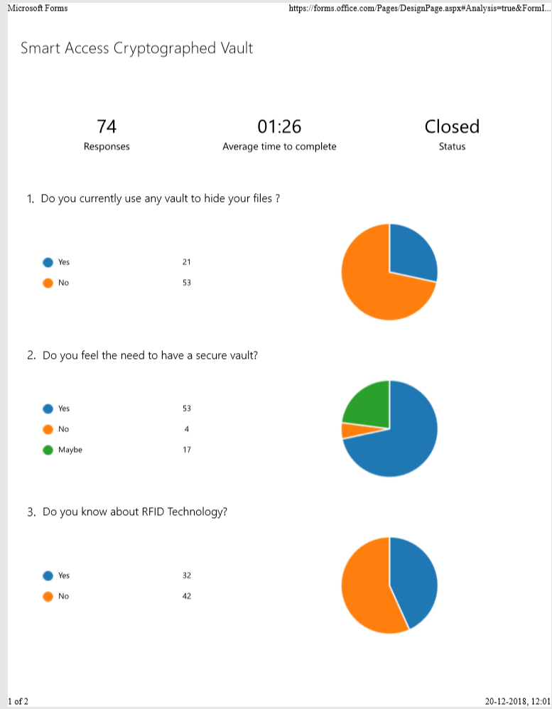

24

